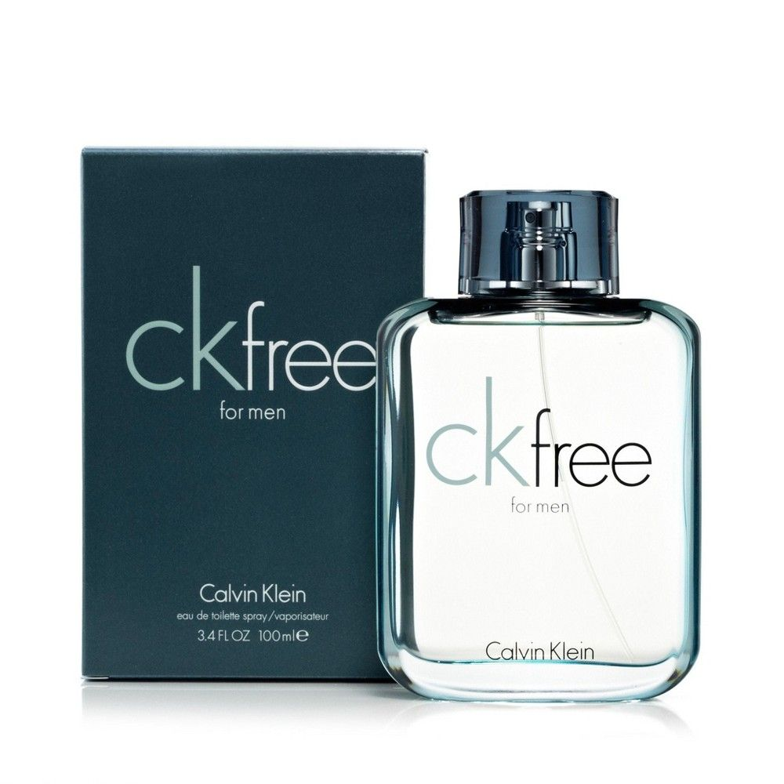
CALVINKLEIN PERFUME
Product Overview
CK Be by Calvin Klein is a fresh and modern unisex fragrance designed for everyday confidence. Its smooth blend of woody and floral notes creates a clean, subtle scent that feels both energizing and elegant. Perfect for daily wear, this fragrance offers a balanced aroma that lasts throughout the day without being overpowering.
Key Features
* Brand: Calvin Klein
* Category: Unisex
* Volume: 200ml
* Fragrance Type: Eau De Toilette
* Long-lasting fragrance performance
* Suitable for daily and casual wear
Pricing
Old Price: Rs. 2500
Discounted Price: Rs. 2250

